Bamba Cisse, Jason Seda, Maurice Agonsi, Romulo Jimenez

Thoughts and outputs:

The initial analysis set out to test the hypothesis that the rate of partnership increases steadily with age. This expectation was largely confirmed by the data presented in "Share Ever Partnered by Age." The graph illustrates a clear trend: the likelihood of having ever been in a partnership rises sharply through a person's 20s, 30s, and 40s, closely following the predicted upward trajectory. This growth begins to level off in middle age, suggesting that most people who will partner have done so by their late 40s or 50s. By their late 70s, the data indicates that partnership is nearly universal, with around 95% of individuals having been partnered at least once. The slight decline observed after age 85 does not contradict the overall trend but likely reflects the painful reality of partner loss due to death in these advanced age groups. In summary, while the majority of the data coincides with the expected average trend of increasing partnership with age, the graph also reveals the nuanced pattern of rapid growth in early adulthood, a plateau in later life, and a final gentle decline in the oldest cohorts.

The Second Graph, reveals two compelling trends in partnership across a person's lifespan by comparing the percentage of individuals who are "currently partnered" against those who have "ever been partnered" (i.e., divorced or widowed at some point).

The first, more expected trend is the steady rise in current partnerships as people move into middle age. However, a more surprising phenomenon emerges later in life. While the likelihood of having been partnered plateaus and even experiences a slight, sudden decrease at the oldest ages, the line for those currently partnered begins a clear decline after middle age.

This creates the graph's most significant insight: a growing gap between the two lines. It highlights a crucial reality of later life. Although the vast majority of older adults have experienced a partnership, a progressively smaller share remains in one. This divergence underscores a substantial increase in the number of people living without a partner in their later years, primarily due to widowhood or divorce, despite having had a partner in the past.

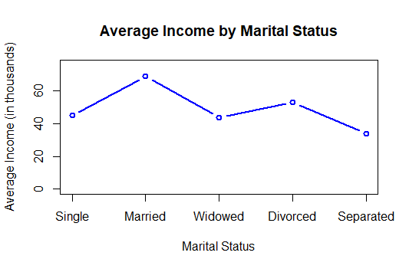

Following, The data avbove reveals a clear and significant financial advantage for married individuals, who report the highest average income. This is substantially higher than singles, who form the second-highest earning group. The data suggests a strong correlation between marriage and economic well-being.

A more striking finding is the pronounced income disparity for widowed, divorced, and separated individuals, who form the lowest earning groups. This indicates that the loss of a partner—whether through death or the dissolution of a marriage—is associated with a considerable decline in average income. The "marriage premium" is evident, while the "widowed/divorced penalty" is severe.

This is likely reflecting the economic benefits of dual incomes, shared resources, and potential tax advantages in marriage, contrasted with the financial challenges faced by single-person households, particularly those resulting from a partner's death or divorce.

Reviewing the final graph, which breaks down each income group (High, Medium, Low) by partnership status across different ages, reveals a more complex story than initially anticipated. The original hypothesis was that higher income would generally correlate with a higher proportion of single individuals, perhaps with a delay caused by marriage rates. However, the actual breakdown is more revealing.

For the High-income bracket, marriage rates spike dramatically early in life. This is followed by a gradual decline, with the proportions of married and divorced individuals eventually converging later in life. In contrast, the Medium and Low-income brackets show a more gradual initial shift from single to married status. The most striking difference emerges in the Low-income group, where divorce rates skyrocket after age 40, while the proportion of married individuals plateaus at a mediocre level. The Medium-income bracket presents a more evenly distributed and less volatile pattern.

In summary, while the goal was to test income's effect on partnership, the results demonstrate that income level has a profound impact not only on the formation of partnerships but also on their longevity.